Orangy Food truck

Features

Creating new/updation /deletion/displaying Truck with the following information

* + Name :
  + URL image of truck:
  + Price or deals:
  + Date of the truck stationed

Technology Used

* + Angular 2
  + Materialization for UI Components
  + Node
  + Express
  + MongoDB

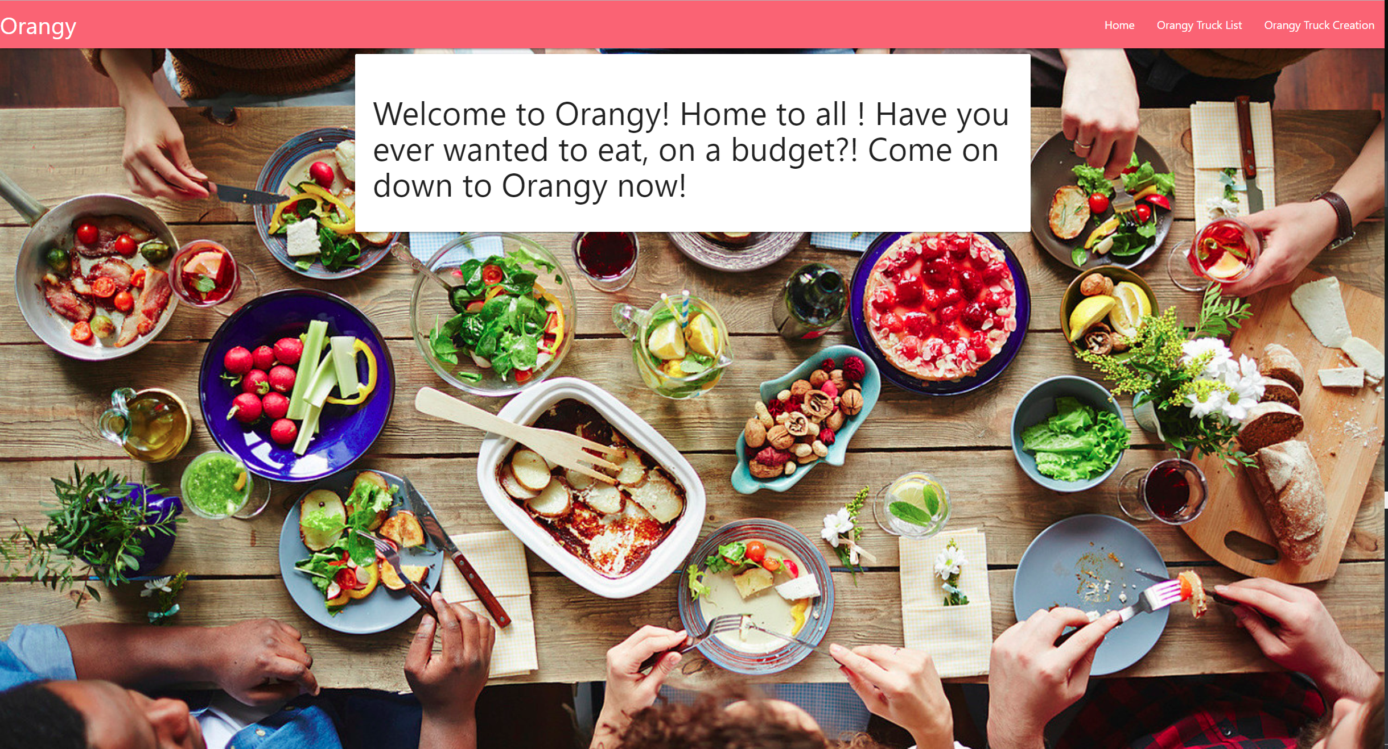

Creation of New truck

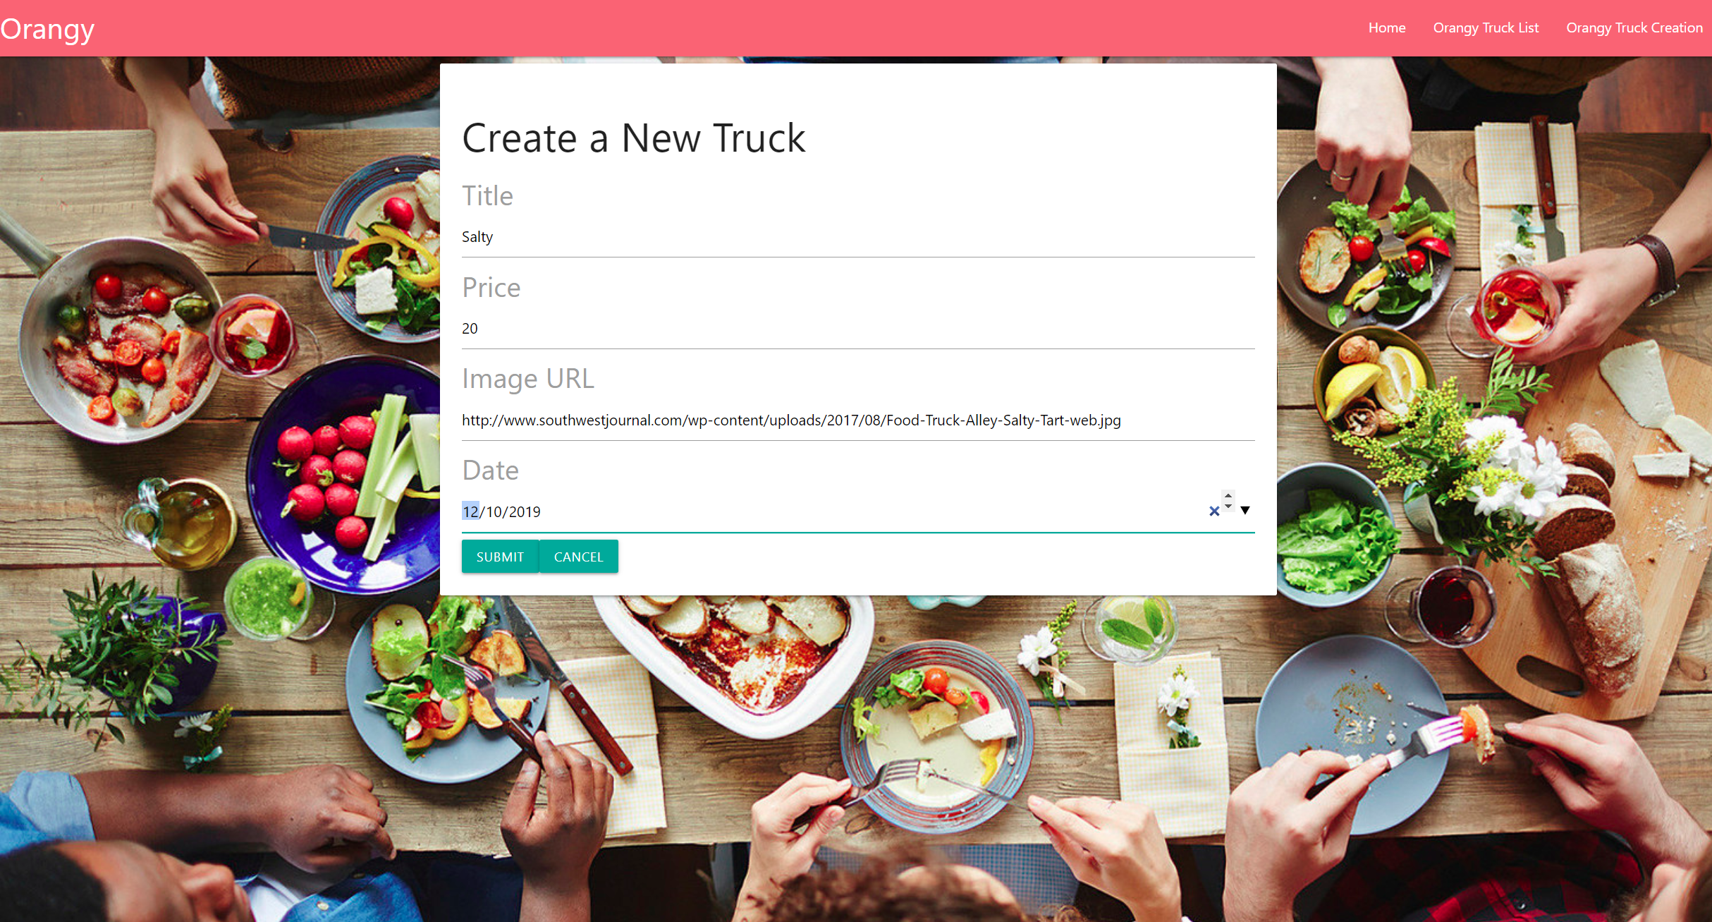

Truck Information updated

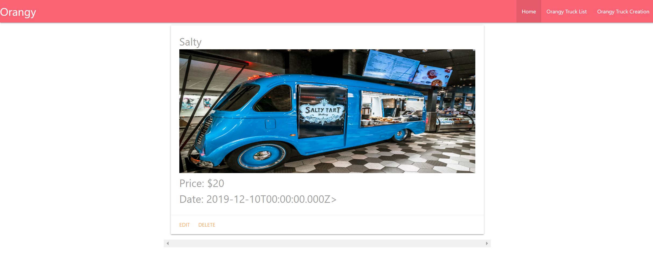Updation or deletion of the information about the truck

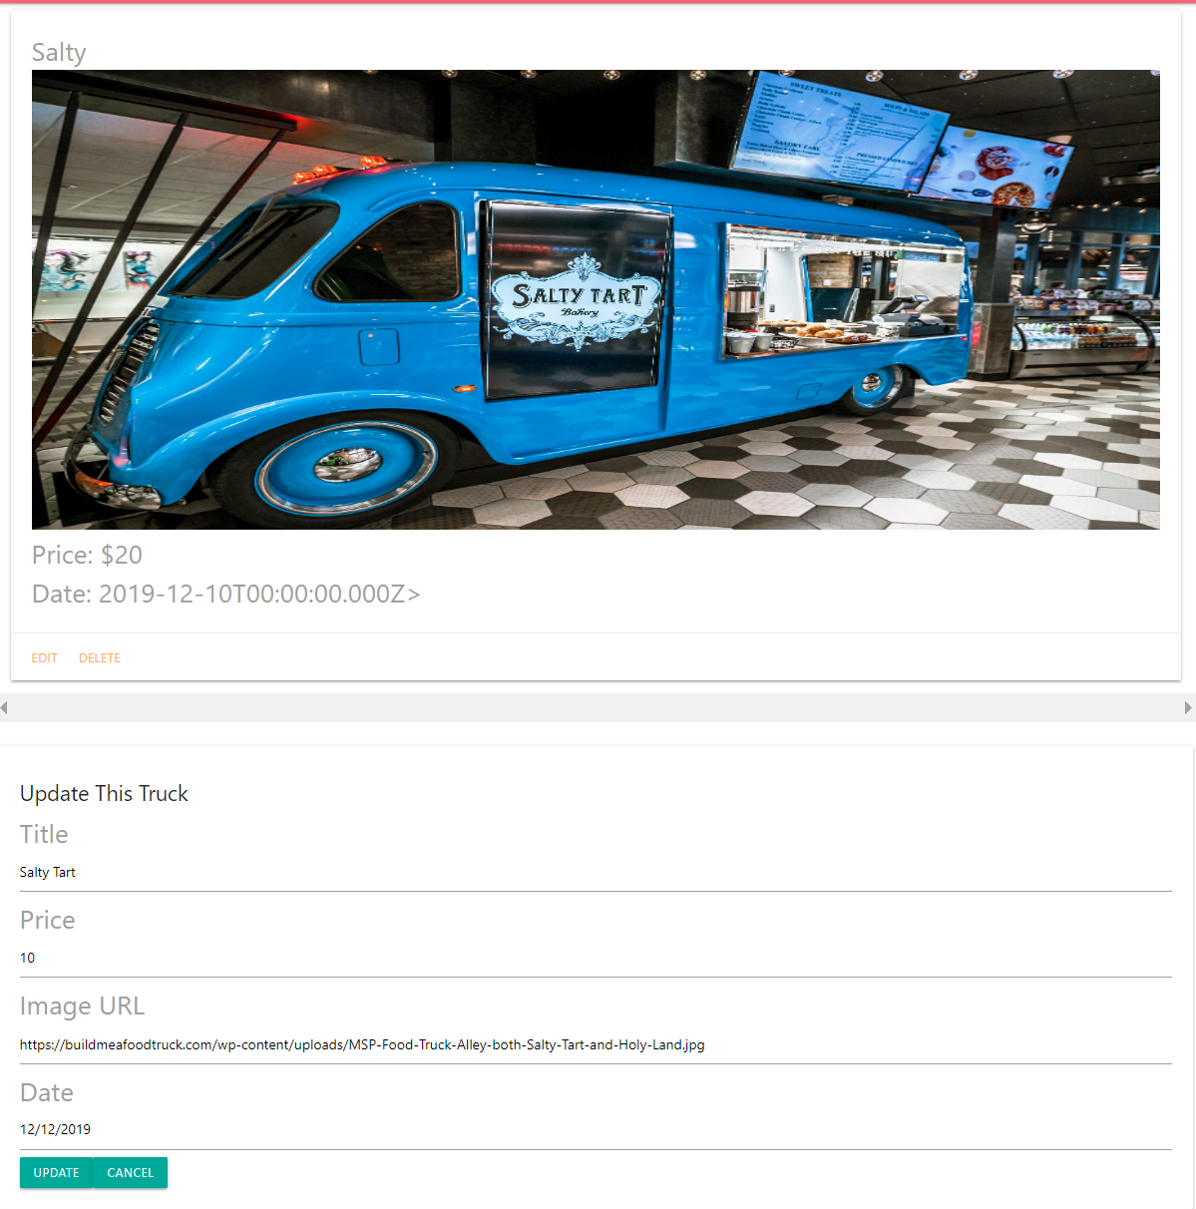

Display Of Truck

